Crop Phenology Estimation

# 1st S.Aruna

*Department of Information Technology vasavi college of engineering* Hyderabad,India [s.aruna@staff.vce.ac.in](mailto:s.aruna@staff.vce.ac.in)

# 2nd Sai Arvind N

*Department of Information Technology vasavi college of engineering* Hyderabad,India [nsaiarvind@gmail.com](mailto:nsaiarvind@gmail.com)

# 3rd KVS Sriya

*Department of Information Technology vasavi college of engineering* Hyderabad,India [sriyakodav](mailto:sriyakodavanti@gmail.com)[anti@gmail.com](mailto:anti@gmail.com)

***Abstract*—The estimation of crop phenology has many benefits, such as assisting with crop classification, irrigation scheduling, and crop production estimation. One main part of crop agricul- ture is the observation of the crops, which is what this project is about. Observation of crops can be done in various ways and these can be used to respond to different situations that might arise during the cultivation of crops. Accurately identifying the timing of crucial growth phases in primary crop-producing areas is crucial for determining the possible decrease in yield due to severe weather phenomena. Examples of these phases include corn silking and soybean pod-filling, which are periods of heightened vulnerability where crop yields are at risk. As the global food supply is expected to face increasing disruptions from extreme weather, it is vital to have this knowledge to effectively manage and mitigate potential yield losses.**

**The project aims to calculate Growing Degree Days, NDVI for aiding Crop Phenology Estimation. With the comparison of GDD, and NDVI for crops in different regions we expect to predict the phenology of a crop in different climatic and environmental conditions. In this study we calculate Surface Temperature from Landsat 8 for predicting GDD and NDVI. This study aims to assess the vegetation health and growing degree days (GDD) of Sangareddy, India using satellite imagery. A computation of Normalized Difference Vegetation Index (NDVI) was performed using Landsat 8 imagery for the years 2018-2021. The NDVI values were analyzed to identify any trends and changes in vegetation health over the years.**

***Index Terms*—NDVI, GDD,Landsat8, Phenology**

1. INTRODUCTION

Agriculture is the science of farming which includes the growth of crops to produce food, rearing of animals to provide wool, and many more. This science has many complications. Today with the increased demand for food, just growing crops is not enough. An efficient practice of growing crops with minimum input and maximum results is required. This need can be satisfied if our progress in information technology can be integrated with conventional farming practices. To propose a novel framework for crop phenology estimation that further enhances the performance with few satellite images. Generally, it is quite flexible and untroubled to classify an image when there are enough samples describing the image, but the difficulty arises when there are very few samples suitable to predict different parameters.

Identify applicable funding agency here. If none, delete this.

For remote monitoring and advisory purposes using satellite imaging, precise estimation of a crop’s phenological growth stage is crucial. There are many practical uses of this method, including but not limited to crop identification, monitoring crop health, determining irrigation schedules, deciding when and how to apply agricultural inputs like soil nutrients, warn- ing farmers of potential diseases, forecasting harvest times, and estimating crop yields.[1]. An example of the importance of accurately identifying a crop’s growth stage is that applying soil nutrients during the panicle stage of a paddy crop can result in higher yields by increasing Chlorophyll and Nitrogen content in the leaves with high photosynthetic rates. Addition- ally, proper irrigation scheduling during the active tillering stage is crucial for optimal crop growth. Timely detection of crop stages can aid in advanced production estimation, which can have a significant impact on crop procurement, monitoring[2], distribution, price structure, and import/export decisions. The measurement of the greenness of crops can be determined using the Normalized Difference Vegetation Index based on the amount of light reflected in visible red and near-infrared bands. The NDVI, which stands for Normalized Difference Vegetation Index, indicates the health and density of vegetation captured in a satellite image, based on the greenness of each pixel. Detecting crop stages early on can lead to more accurate production estimation and enable the prediction of crop health. With the comparison of GDD for crops in different regions we expect to predict the phenology of a crop in different climatic and environmental conditions[3]. The scope of this project is to develop a machine learning framework for predicting NDVI, and GDD which in turn helps in predicting crop phenology progress. The project focuses on two key areas: surface temperature calculation and NDVI prediction. The goal is to identify the most effective methods for addressing these challenges and to develop a machine-

learning model that accurately predicts these parameters.

1. METHODOLOGY

In this section, the primary methodology suggested for the crop phenological parameter is outlined using the following two main steps : (i) calculating Normalised Dense Vegetation Index using Landsat8 satellite images and (ii) calculating Land Surface Temperature for evaluating Growing Degree Days.



Fig. 1. NDVI Formula

1. *NDVI Calculation*

The health of plants can be determined through the use of satellite imagery with the help of NDVI indicator and can also detect drought conditions. During the rainy season, NDVI tends to be higher, with a maximum value of +1, while in the dry season, NDVI drops and can reach a minimum value of - 1.NDVI is seen as seasonal in nature but due to climate change upward/downward changes are also observed over the years. Knowing the trend and seasonal cycle of NDVI in advance can help better resource planning and deployment for the local and national stakeholders. There are many known and unknown parameters that influence NDI. Out of many approaches, one would be training machine learning models with past data to get predictions. This notebook will outline two of the machine- learning approaches for NDVI prediction. In the first part, NDVI was extracted from time-series Landsat 8 data image data in Google Earth Engine (GEE) platform through Python API. In the next part, predictive models were built to forecast NDVI using state-of-the-art Prophet models. NDVI of every image pixel in the images will be calculated by the equation: The B5 band represents the Near Infrared (NIR) and the B4 band represents the Red band. The average NDVI will be calculated on every image to get the time-series NDVI of the

AOI.

1. *Land Surface Temperature*

Landsat 8 images can be utilized to compute land surface temperature (LST) by employing the thermal bands of the satellite. The temperature of the Earth’s surface can be es- timated using the thermal bands of Landsat 8 images, as they measure the radiation emitted by the surface in the thermal infrared spectrum.

There are different algorithms available for calculating LST from Landsat 8 thermal bands[4][5], including the split- window algorithm, the single-channel algorithm, and the radia- tive transfer equation-based algorithm. There are advantages and limitations to each algorithm, and the selection of a particular algorithm is based on the specific research question and application at hand.

In general, the split-window algorithm is commonly used for Landsat 8 LST calculation as it is simple and effective. The algorithm utilizes the radiance temperature readings from two thermal bands, which are usually band 10 and band 11 to calculate LST. The algorithm accounts for the atmospheric [6]effects on the thermal bands, such as atmospheric water vapor and atmospheric transmittance, which can affect the accuracy of the LST calculation.

In Earth Engine[8][9], The split-window algorithm can be employed to compute the land surface temperature (LST)

Fig. 2. SW Algorithm for calculating land Surface Temperature

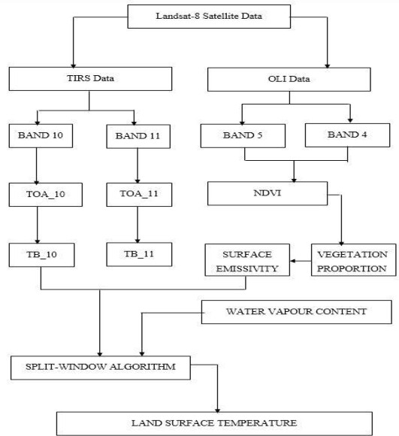by integrating the thermal bands with suitable coefficients and applying the algorithm to the image. The output of the algorithm(Figure 2) is an LST image, which can be used for various applications, including land cover classification, urban heat island studies, and agricultural monitoring.

1. *Growing Degree Days*

GDD can be calculated using the temperature data. GDD is the accumulation of heat above a certain threshold temperature that is required for plant growth. The threshold temperature varies with the specific crop being studied. To calculate GDD, the daily average air temperature is subtracted from the threshold temperature, and the sum of these differences over the growing season is calculated

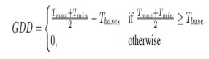

where Tmax was determined as the daily maximum tem- perature, while Tbase was set to 8°C and Tmin was the daily minimum temperature.

1. EXPERIMENTAL SETUP
2. *Data Sets*

Landsat 8, a satellite mission managed by the United States Geological Survey (USGS), offers worldwide coverage of the Earth’s surface at a spatial resolution of 30 meters. The



Fig. 3.

satellite was launched in 2013 and carries two main sensors: the Operational Land Imager (OLI) and the Thermal Infrared Sensor (TIRS). The OLI includes nine spectral bands, covering a broad range of wavelengths from visible to near-infrared, while the TIRS comprises two thermal infrared bands.

1. *Prophet Algorithm*

Facebook Prophet is a time series forecasting tool that employs a generalized additive model (GAM) to model the trend, seasonality, and holiday effects in a time series. The GAM framework allows for modeling complex associations between the response variable (e.g. NDVI) and the predictor variables that exist which are not linear in nature (e.g., time, temperature), as well as for incorporating external regressors that may affect the response variable.

Prophet models the trend as a piecewise linear function, with changepoints that allow for the trend to change direction at specific times. The seasonality is modeled using the Fourier series with a user-defined number of harmonics, which can capture complex seasonal patterns in the data. The holiday effects are modeled using indicator variables, which allow for modeling specific events or periods that may affect the time series (e.g., droughts, floods).

Prophet uses a Bayesian approach to estimate the model parameters and to make predictions. The estimation of model parameters is performed through the utilization of the Markov Chain Monte Carlo (MCMC) sampling technique, which al- lows for obtaining posterior distributions for the parameters and for quantifying uncertainty in the predictions. The pos- terior distributions are used to generate samples from the predictive distribution, which can be used to obtain point estimates and uncertainty intervals for the predicted values.

Prophet also provides various diagnostics and visualization tools to evaluate the model performance and to diagnose any issues with the data or the model. These include residual plots, cross-validation metrics, and interactive plots that allow for visualizing the model components and the predicted values.

Prophet was used to predict NDVI time series and NDVI values from remote sensing sources were preprocessed to remove noise and missing values and load the data into Prophet. The model was trained using a subset of the data for training the model, while the remaining data is reserved for validation or testing purposes. The trained model was used to make predictions for future time points or to forecast the entire time series. The output of the model includes point estimates and uncertainty intervals for the predicted values, which were used to evaluate the accuracy and reliability of the predictions.

1. *Split Window Algorithm*

The split-window algorithm is a widely used thermal in- frared remote sensing method for estimating the land surface temperature (LST) of the Earth’s surface. The algorithm is based on the fact that atmospheric transmittance and emissivity vary with wavelength and that these variations can be exploited to estimate the LST. It uses the brightness temperature (TB) of two TIR bands, one at a shorter wavelength and another at a longer wavelength, which is selected such that the atmospheric transmittance and emissivity are different. The algorithm assumes that the surface emissivity is constant and known for the two bands. The TB of the two bands are retrieved from the satellite data and atmospheric correction is applied to account for the absorption and emission of the atmosphere. The LST is then calculated using a regression equation that relates the TB of the two TIR bands to the LST. The regression equation used in algorithms is generally obtained from a mix of theoretical models and empirical measurements. The algorithm’s precision can be impacted by a variety of factors including surface emissivity, atmospheric conditions, and the precision of the calibration sites utilized in deriving the regression equation.

One advantage of the split-window algorithm is its sim- plicity, as it only requires two TIR bands and a regression equation to estimate the LST. It also has the advantage of being less sensitive to atmospheric effects compared to other TIR algorithms that use a single band. Furthermore, the algorithm can also be applied to large-scale remote sensing datasets to create high-resolution maps of Land Surface Temperature (LST) with both high spatial and temporal accuracy.

1. PRELIMINARY RESULTS

TABLE I shows the Prophet model performance for pre- dicting NDVI. The Model was trained solely on Sangareddy District Dataset.

TABLE I

PROPHET MODEL METRICS

|  |  |  |  |
| --- | --- | --- | --- |
| **Model**  **Name** | **Metrics** | | |
| ***MSE*** | ***MAE*** | ***RSME*** |
| Prophet | 0.001827 | 0.037646 | 0.042743 |

a

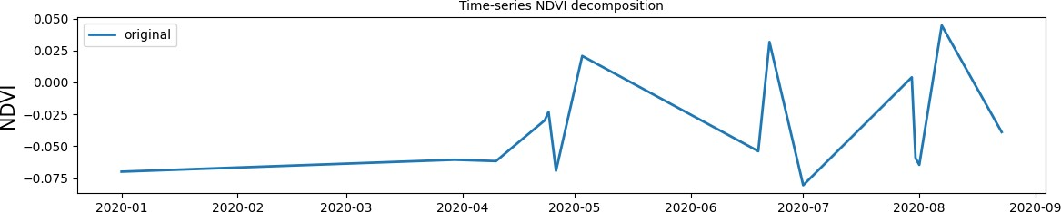

Fig 4. NDVI Original

This refers to the NDVI values calculated from satellite data without any further processing. Original NDVI values were used to analyze vegetation cover and productivity over time, and to identify areas with different vegetation types and densities.

*ˆ*

Fig 5. NDVI Seasonal

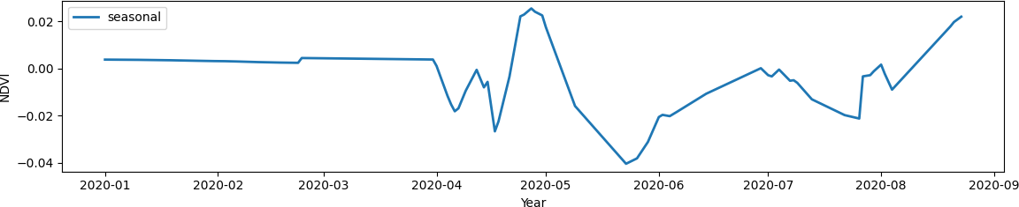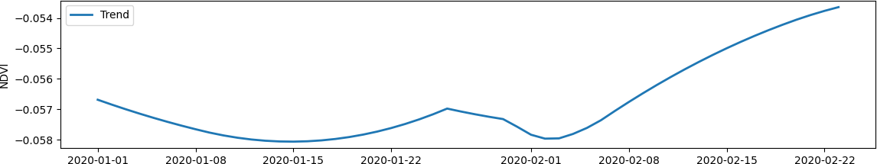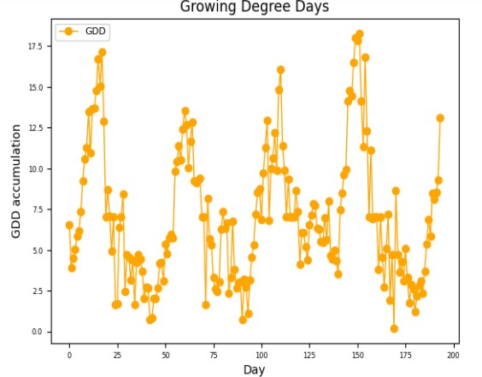

This type of NDVI analysis involves separating the NDVI values into seasonal or monthly averages. This allowed for the identification of seasonal variations in vegetation cover and productivity, such as the onset and end of growing seasons, and the effects of weather patterns on vegetation growth.

Fig 6. NDVI Trend

This NDVI Trend gives us insights into analyzing the long- term trends in NDVI values over a period of time, typically several years or decades. The NDVI trend analysis identifies changes in vegetation cover and productivity over time, this may include impacts arising from events like climate change, land use alterations, or natural disruptions such as wildfires or deforestation.

Fig 7 represents the performance of NDVI values from the Prophet algorithm to actual values evaluated from LandSat8. The Prophet algorithm was one of the best algorithms with high accuracy.

1. CONCLUSION AND FUTURE SCOPE

The method suggested was implemented in a moderately sizable region of India, and we discovered a relatively small number of images.

Given that the duration between two captured timestamps is 5 days or greater, this is a noteworthy accomplishment for satellite data with medium-temporal resolution. The primary obstacle encountered during the implementation of this ap- proach across the whole area was the availability of fewer images due to longer periods of cloudy days. Using Image Fusion Techniques there is scope to increase the availability of images. This also enables us to map phenology by within- season approaches [10][11]for real-time monitoring.

REFERENCES

1. J. Huang, H. Wang, Q. Dai and D. Han, ”Analysis of NDVI Data for Crop Identification and Yield Estimation,” in IEEE Journal of Selected Topics in Applied Earth Observations and Remote Sensing, vol. 7, no. 11, pp. 4374-4384, Nov. 2014, doi: 10.1109/JSTARS.2014.2334332.
2. .Y. Shen, G. Shen, H. Zhai, C. Yang and K. Qi, ”A Gaussian Kernel- Based Spatiotemporal Fusion Model for Agricultural Remote Sensing Monitoring,” in IEEE Journal of Selected Topics in Applied Earth Observations and Remote Sensing, vol. 14, pp. 3533-3545, 2021, doi: 10.1109/JSTARS.2021.3066055.
3. Z. Xu et al., ”Trends in Global Vegetative Drought From Long-Term Satellite Remote Sensing Data,” in IEEE Journal of Selected Topics in Applied Earth Observations and Remote Sensing, vol. 13, pp. 815-826, 2020, doi: 10.1109/JSTARS.2020.2972574.
4. F. Zhang et al., ”Cloud-Free Land Surface Temperature Reconstructions Based on MODIS Measurements and Numerical Simulations for Char- acterizing Surface Urban Heat Islands,” in IEEE Journal of Selected Topics in Applied Earth Observations and Remote Sensing, vol. 15, pp. 6882-6898, 2022, doi: 10.1109/JSTARS.2022.3199248.
5. S. Li and G. -M. Jiang, ”Land Surface Temperature Retrieval From Landsat-8 Data With the Generalized Split-Window Algorithm,” in IEEE Access, vol. 6, pp. 18149-18162, 2018, doi: 10.1109/AC- CESS.2018.2818741.
6. 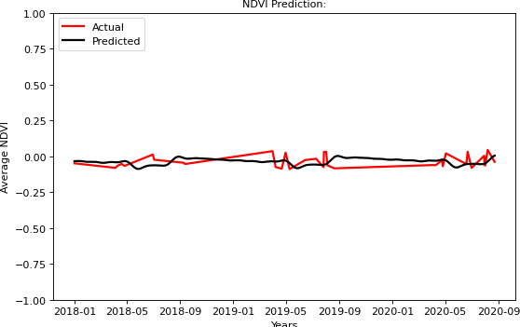R. Niclo`s, J. A. Valiente, M. J. Barbera` and V. Caselles, ”Land

Fig 7. Prophet Algorithm Prediction for NDVI

This result helps us to understand the trend of NDVI and also these can be used further in phenology[10] prediction for crop growth stages.

Fig 8 represents Growing Degree Days accumulated over the crop cycle from Jan 2018-June 2018 solely in Sangareddy district.

Surface Air Temperature Retrieval From EOS-MODIS Images,” in IEEE Geoscience and Remote Sensing Letters, vol. 11, no. 8, pp. 1380-1384, Aug. 2014, doi: 10.1109/LGRS.2013.2293540.

1. X. Liu et al., ”Large-Scale Crop Mapping From Multisource Remote Sensing Images in Google Earth Engine,” in IEEE Journal of Selected Topics in Applied Earth Observations and Remote Sensing, vol. 13, pp. 414-427, 2020, doi: 10.1109/JSTARS.2019.2963539.
2. G. Lemoine and O. Le´o, ”Crop mapping applications at scale: Using Google Earth Engine to enable global crop area and status monitoring using free and open data sources,” 2015 IEEE International Geoscience and Remote Sensing Symposium (IGARSS), Milan, Italy, 2015, pp. 1496-1499, doi: 10.1109/IGARSS.2015.7326063.
3. A. Shelestov, M. Lavreniuk, N. Kussul, A. Novikov and S. Skakun, ”Large scale crop classification using Google earth engine platform,” 2017 IEEE International Geoscience and Remote Sensing Sympo- sium (IGARSS), Fort Worth, TX, USA, 2017, pp. 3696-3699, doi: 10.1109/IGARSS.2017.8127801.
4. Z. Yang, C. Diao and F. Gao, ”Towards Scalable Within-Season Crop Mapping With Phenology Normalization and Deep Learning,” in IEEE Journal of Selected Topics in Applied Earth Observations and Remote Sensing, vol. 16, pp. 1390-1402, 2023, doi: 10.1109/JS- TARS.2023.3237500.
5. K. K. Gadiraju and R. R. Vatsavai, ”Application of Transfer Learning in Remote Sensing Crop Image Classification,” in IEEE Journal of Selected Topics in Applied Earth Observations and Remote Sensing, doi: 10.1109/JSTARS.2023.3270141.
6. https://earthexplorer.usgs.gov/ Landsat8 dataset link